Week 3 Internship Documentation
Infosys Springboard Internship | Data Visualization Domain
Topic Focus: Practical Power Query, Advanced Cleaning Functions, and Git & GitHub Basics
Prepared by: Hindu Priya Boddu
Project: Optimizing IT Support Team Performance Using Analytics


1. Introduction
Week 3 focused on practical execution of Power Query transformations in live class, advanced data cleaning functions, detailed null handling methods, and the introduction of Git and GitHub for project version control. This week was highly important because it transformed earlier conceptual learning into actual hands-on workflow that can be applied directly in real analytics projects.

2. Practical Use of Power Query in Live Class by Students and Team
During the live class sessions, the instructor demonstrated real-time Power Query operations on a sample dataset while students followed the same steps on their own systems. This method helped learners understand the sequence of transformations, the importance of the Applied Steps pane, and how multiple cleaning operations work together to make data analysis-ready.
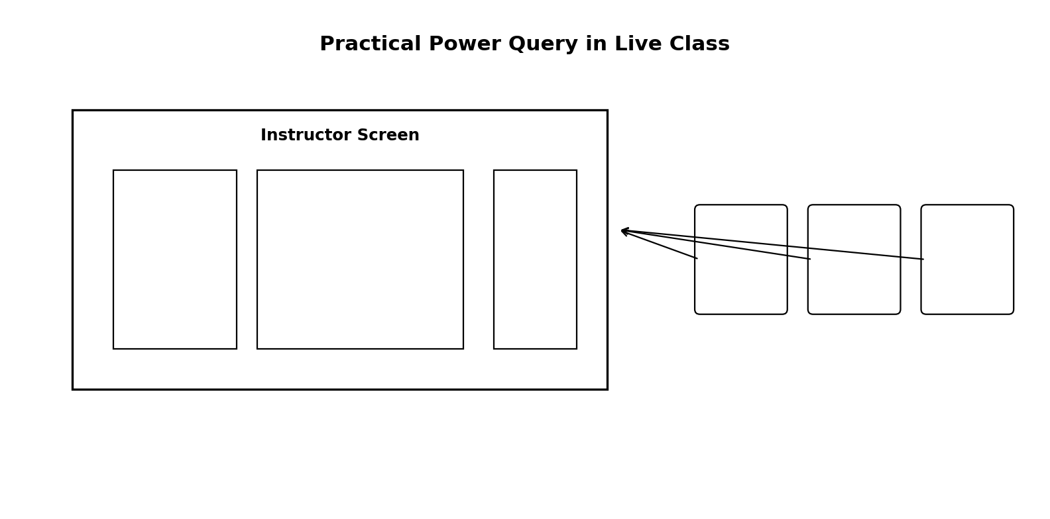
Figure 1: Illustrative representation of Power Query practical learning in live class
- Students imported raw datasets and inspected column quality
- The team practiced replacing inconsistent values and correcting formats
- Live demonstrations improved confidence in real project execution
- Applied Steps showed each transformation in a structured order

3. Advanced Functions of Power Query
Function | Purpose | Business Use
Replace Values | Correct inconsistent values | Standardize categories for accurate reporting
Conditional Column | Create rule-based classifications | Label urgent tickets or delayed cases
Trim / Clean | Remove spaces and hidden characters | Prevent duplicate-looking categories
Lower / Upper / Capitalize | Standardize text case | Improve grouping and readability
Fill Down / Fill Up | Propagate nearby values | Handle structured missing values
Split Column | Divide combined values | Separate name, code, or category parts
Group By | Summarize data before loading | Pre-aggregate at query stage
Pivot / Unpivot | Reshape data | Prepare wide or long format tables

4. Replace Values
Replace Values is one of the most commonly used Power Query transformations. It helps correct inconsistent labels, remove unwanted symbols, standardize text values, and make categories uniform. For example, 'high', 'High', and 'HIGH' can all be standardized to 'High' for accurate counting in visuals.

5. Data Type Correction
Column | Recommended Type | Why
Ticket ID | Text | Avoid accidental summation of IDs
Date of Purchase | Date | Required for date analysis and filtering
First Response Time | Decimal / Duration | Used in KPI calculations
Time to Resolution | Decimal / Duration | Needed for performance analysis
Customer Satisfaction Rating | Whole Number / Decimal | Needed for average score
Customer Email | Text | Identifier should remain text

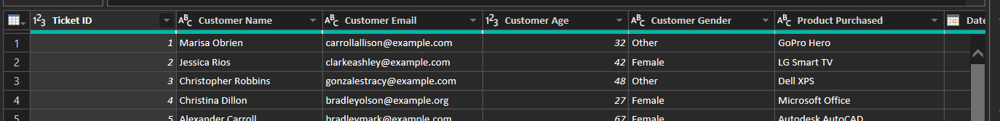
Figure 2: Illustrative Data Types of dataset column

6. Trim / Clean / Lower / Upper / Capitalize
Function | Meaning | Example
Trim | Removes leading and trailing spaces | ' High ' → 'High'
Clean | Removes non-printable characters | Removes tabs and hidden breaks
Lowercase | Converts all text to lowercase | 'FEMALE' → 'female'
UPPERCASE | Converts all text to uppercase | 'male' → 'MALE'
Capitalize Each Word | Capitalizes each word | 'ticket status' → 'Ticket Status'
A good practical order is: Trim → Clean → Lowercase/Uppercase → Capitalize Each Word.
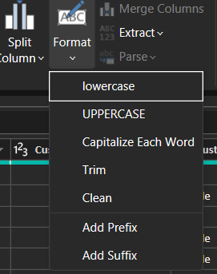

7. Standardizing Text Values and Data
Standardization ensures that logically identical values are stored in one consistent format. This is essential because Power BI groups values using exact text matches.
- Priority values: high / High / HIGH → High
- Gender values: male / Male / M → Male
- Channel values: email / Email / E-mail → Email
- Status values: open / Open / OPEN → Open

8. Null Handling in Analytics
Null values represent missing data. In analytics, nulls must be handled carefully based on business meaning, percentage of missingness, and column type.
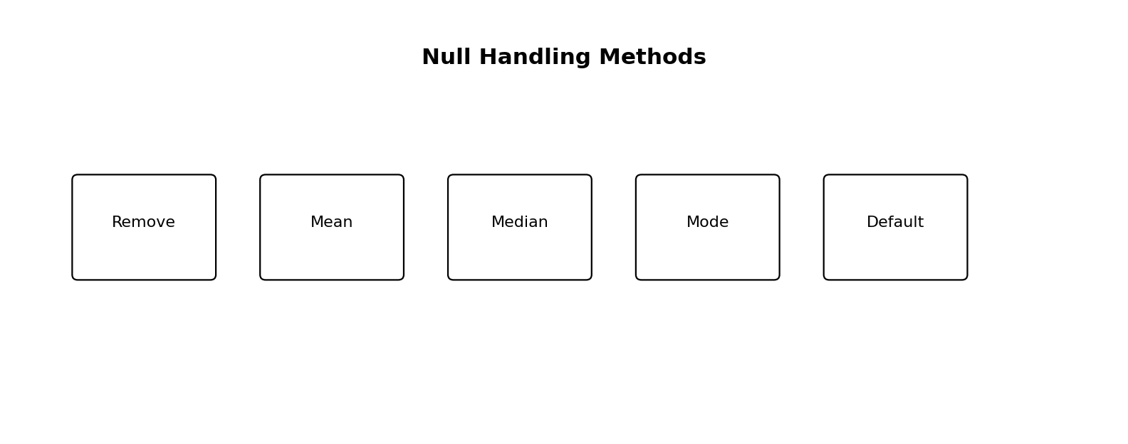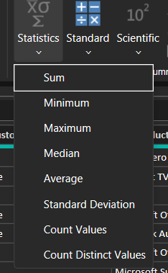

Figure 2: Common null handling approaches
- Remove rows when nulls are very few and non-critical
- Use Mean for normal numeric data
- Use Median when data contains outliers
- Use Mode for categorical values
- Use business defaults such as 'Unknown' for text columns

9. Null Handling with Mean, Median, and Mode (Detailed)
Method | Best For | How It Works | When to Avoid
Mean | Continuous numeric data | Replace null with average of non-null values | Avoid when outliers strongly affect average
Median | Skewed numeric data | Replace null with middle value | Less useful for tiny samples
Mode | Categorical or repeated values | Replace null with most frequent value | Avoid when no dominant category exists
Mean example: if First Response Time values are 2, 4, 6, and null, the mean of non-null values is 4. The null can be replaced with 4 if the data is reasonably balanced.
Median example: if Time to Resolution values are 2, 3, 4, 20, and null, the median is safer than mean because the outlier 20 can distort the average.
Mode example: if Ticket Channel values are Email, Chat, Email, Phone, and null, the mode is Email. The null may be replaced with Email if the business context supports it.
Important: For text columns such as Resolution or Customer Name, statistical methods like mean or median are not appropriate. In such cases, use blank, Unknown, or a defined business label.

10. Practical Null Handling Recommendations for Your Dataset
Column | Recommended Handling | Reason
Customer Name | Unknown / keep blank | Text identifier
Customer Gender | Unknown | Categorical demographic
Ticket Priority | Mode or business default | Categorical field
First Response Time | Mean or Median | Numeric performance metric
Time to Resolution | Median preferred if outliers exist | Resolution times are often skewed
Customer Satisfaction Rating | Mean or Median | Numeric score
Resolution | Blank / Not Provided | Text field

11. Conditional Columns
Conditional Columns create a new column based on logical rules and are very useful for classification and segmentation.
- If Satisfaction Rating >= 4 then 'Satisfied' else 'Needs Improvement'
- If Time to Resolution > 24 then 'Delayed' else 'On Time'
- If Ticket Priority = 'High' then 'Urgent' else 'Normal'

12. Remaining Important Power Query / Power BI Functions
- Merge Columns
- Extract Before / After Delimiter
- Add Index Column
- Group By
- Pivot / Unpivot Columns
- Transpose
- Use First Row as Headers
- Promote / Demote Headers
- Rename Columns
- Close & Apply

13. Git & GitHub Basics
Git is a version control system that tracks file changes over time. GitHub is a cloud platform where Git repositories are stored and shared. In analytics projects, these tools help manage documentation, project files, and progress history professionally.

14. GitHub Repository Structure for Analytics Project

Folder / File | Purpose
README.md | Project overview, problem statement, dataset description, insights
data/raw_data/ | Original dataset files
data/processed_data/ | Cleaned and transformed datasets
reports/ | Weekly documentation, PDFs, Word files
dashboard/ | Power BI file or dashboard screenshots
images/ | Screenshots and visuals for README

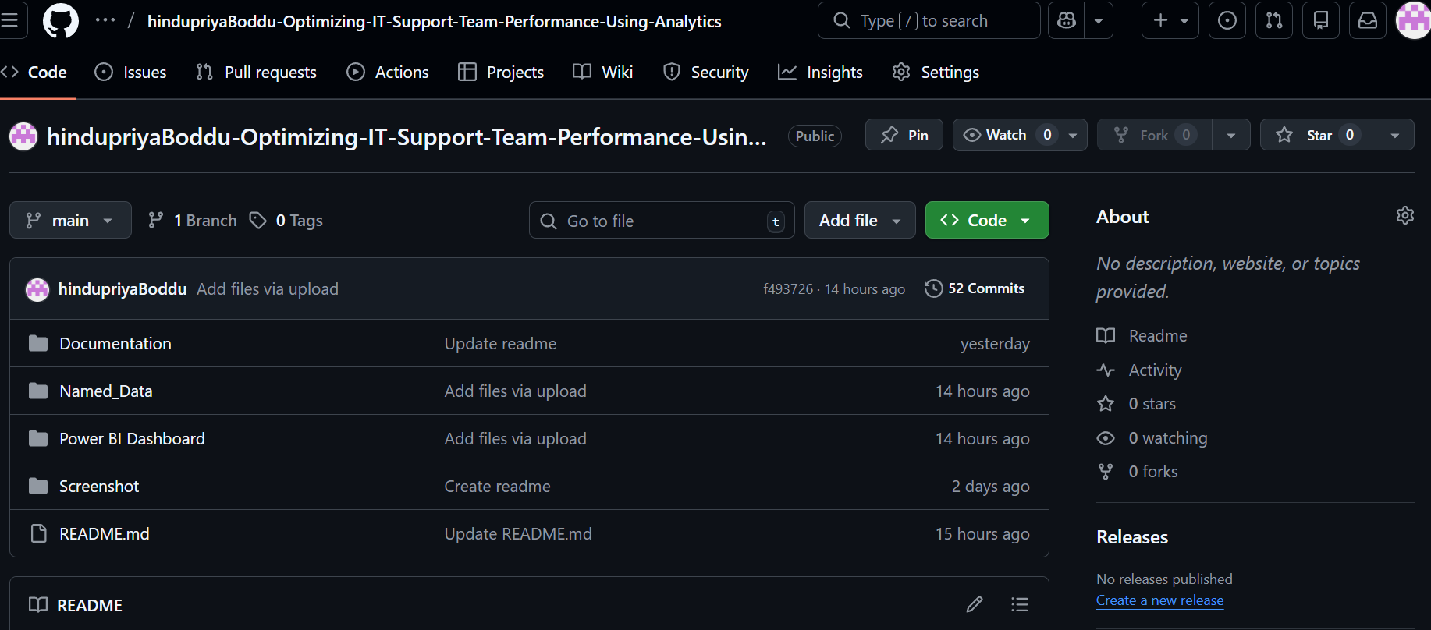
Figure 3: GitHub profile

Github Link

15. Commit / Push Workflow

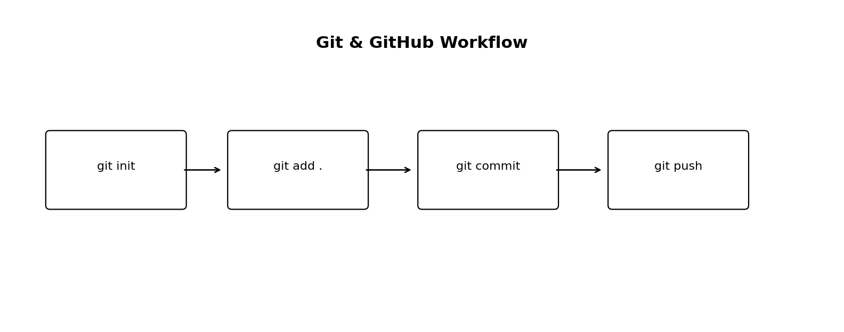
Figure : Basic Git and GitHub workflow
- git init – Initialize local repository
- git add . – Stage files
- git commit -m 'message' – Save a version snapshot
- git remote add origin <repo-link> – Connect to GitHub
- git push -u origin main – First upload
- git push – Upload later changes

16. Importance of Version Control in Analytics Projects
- Tracks weekly progress across internship work
- Keeps old versions of reports and files safe
- Supports collaboration and review
- Makes the project more professional for mentors and recruiters
- Improves reproducibility and accountability

17. Best Practices Learned in Week 3
- Always standardize text before building visuals
- Check data types after each major transformation
- Use median instead of mean when outliers are strong
- Do not apply statistical imputation to text fields
- Use conditional columns for rule-based categories
- Keep Git commits small and meaningful
- Maintain a clean GitHub repo structure

18. Week 3 Learning Summary
Week 3 was a strong practical milestone. It covered live Power Query usage, advanced cleaning functions, detailed null handling methods including mean, median, and mode, and professional project management using Git and GitHub. These skills directly support the next stages of the internship such as KPI creation, dashboard development, and project presentation.

20. Conclusion
Week 3 strengthened both technical and professional aspects of the internship. On the technical side, it improved practical proficiency in Power Query and advanced cleaning. On the professional side, it introduced Git and GitHub, which are essential for managing analytics projects in a structured and industry-ready manner.

